**How do you determine the number of clusters (K)?**

* Using the Elbow Method, the elbow point determined is 2.

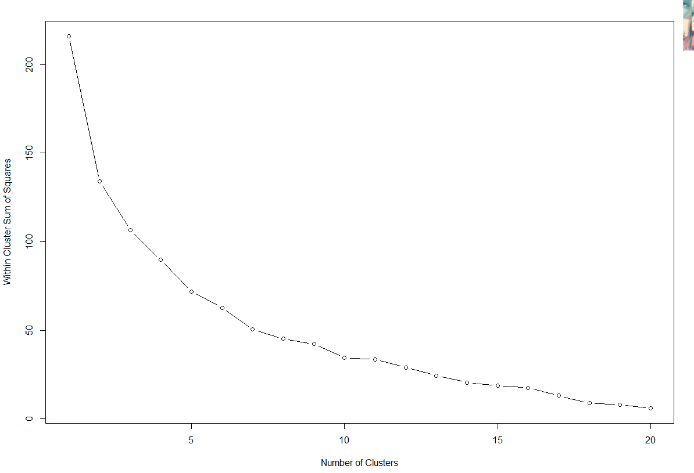

|  |  |  |  |  |  |
| --- | --- | --- | --- | --- | --- |
|  | Cluster 1 | Cluster 2 | Cluster 3 | Cluster 4 | Cluster 5 |
| #Instances | N = 5 | N = 4 | N = 8 | N = 4 | N = 4 |
| Countries | Czech  Germany  Hungary  Poland  Russia | Albania  Bulgaria  Romania  Yugoslavia | Austria  Belgium  France  Ireland  Netherlands  Switzerland  UK  W Germany | Greece  Italy  Portugal  Spain | Denmark  Finland  Norway  Sweden |
| Centers (Food) | Starch | Cereals | Red Meat  White Meat  Eggs | Nuts  Fruit & Veggies | Milk  Fish |

The above cluster both the country and the food by their closest records. Followed by clustering the countries to the most common or popular source of food cluster consumed by them.

**Which distance measure(s) is used for clustering (for hierarchical clustering)?**

Hierarchical Clustering by Countries (4 Cluster, Average Distance)

|  |  |  |  |  |
| --- | --- | --- | --- | --- |
|  | Cluster 1 | Cluster 2 | Cluster 3 | Cluster 4 |
| #Instances | N = 6 | N = 15 | N = 2 | N = 2 |
| Country | Albania  Bulgaria  Hungary  Romania  Russia  Yugoslavia | Austria  Belgium  Czech  Denmark  Germany  Finland  France  Ireland  Netherlands  Norway  Poland  Sweden  Switzerland  UK  W.Germany | Greece  Italy | Portugal  Spain |

The above cluster all the country into 4 clusters based on their closeness of protein consumption habits.

Hierarchical Clustering by Food Sources (4 Cluster, Average Distance)

|  |  |  |  |  |
| --- | --- | --- | --- | --- |
|  | Cluster 1 | Cluster 2 | Cluster 3 | Cluster 4 |
| #Instances | N = 4 | N = 2 | N = 2 | N = 1 |
| Foods | Red Meat  White Meat  Eggs  Milk | Fish  Starch | Cereals  Nuts | Fruit & Veggies |

The above cluster the food into 4 different cluster based on it similarity and closest form of food consumption pattern.

**Evaluate the Business Problem**

This clusters can help managers to do understand on which are the protein source that are more popular in the different country and clustering the food based on the similarity or closeness. Thus, with this information, managers can do marketing decisions or promote the more relevant or popular food for the cluster of countries.